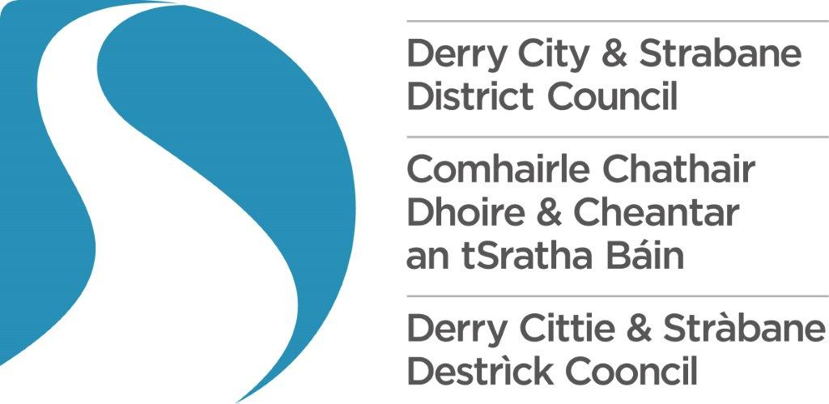

Community

Festival Fund

**2024/25**

Scoring Matrix

# **Derry City and Strabane District Council Community Festival Fund 2024/25**

**Scoring Matrix**

The following Scoring Matrix has been developed for the community festival grant programme.

Name of Organisation:

Reference Number:

|  |  |  |
| --- | --- | --- |
| Question Number | **Max**  **Score** | **Score** |
| 1. **Please outline the aims and objectives for your festival and provide an overview of your proposed programme?**  * Relevance of aim(s) and objectives for a community festival * Explanation around festival dates, locations and venues chosen given * Reference to community festival/event and or reference to cultural expression/celebration in their constitution * Programme retains consistent artistic/cultural vision across festival * Proposed programme aligned with aims and objectives * Programme is of high quality and innovative * If a digital programme only is proposed please outline details of production quality, quality of proposed programme etc.   **Failure to achieve a quality threshold of 50% in this question will result in your application failing at this stage.** | 20 |  |
| 2. Please explain how your festival will engage with your community in the design of the programme and delivery of the event.  * Detail of relevant community and proposed consultation and engagement processes * Illustration of previous success in community participation * Specific details regarding community participation including numbers and practical examples of participation * Evidence of creative and meaningful community engagement and participation. | 10 |  |

|  |  |  |
| --- | --- | --- |
| **3. How will your festival help people within your community through volunteering opportunities?**  Detail on volunteer recruitment and retention including:   * Plan for recruitment (including target numbers) * Training schedule for volunteers * Detail on retention of volunteers post event   Will volunteers and organisers be able to:   * Develop their personal confidence * Create new connections with other people and organisations * Gain new skills and/or qualifications (relevant to arts, culture, community activity or employment) | 10 |  |
| **4. How will your festival enable your community to express and celebrate their cultural heritage?**   * Detail regarding the cultural heritage of the community provided * Illustration of how the proposed programme reflects this cultural heritage * Is there the opportunity for the festival to create a greater understanding of the community’s cultural heritage? | 5 |  |
| **5. How will you ensure that hard to reach groups will engage with your festival as volunteers, participants and audience?**   * Have they made suitable provisions to facilitate the engagement of the pan disability community * Can they illustrate how they will secure the participation of other hard to reach groups including section 75 groups | 5 |  |
| **6. What management systems will you have in place in order to ensure that your festival is delivered safely and successfully and that your grant is administered appropriately?**   * Demonstrate good governance and robust financial, health & safety and event management systems * Outline reporting management processes and procedures * Experience of successful delivering festivals or events of similar scale * Identification of key personal as well as relevant expertise and experience * Highlight track record of partnership working * Are there any conflict of interest situations with regard to this application and how have these been managed and recorded? | 5 |  |
| **Q7. Outline the marketing plan for your festival**   * Information on target audience profile and estimated numbers * Proposed Marketing activities to be undertaken, when and by whom. * Demonstration of creative marketing techniques and potential exploitation of partnership working * Illustrate how the impact of the proposed marketing plan will be measured and evaluated | 10 |  |
| **Q8. How will your organisation contribute to the fulfilment of the NW Audience Development Plan?**   * Can they illustrate how they will contribute to the fulfilment of the actions detailed with the NW Audience Development Plan? * Will they effectively engage families over the next year? * Will they effectively engage older people over the next year? | 5 |  |
| **9. Please outline how you will ensure that the required festival impact questionnaires are completed and submitted.**   * Do they have a plan in place to ensure that the required surveys are completed and returned * Have they detailed the dedicated resource to be allocated to this task | 5 |  |
| **10.Targeted Social Need - Super Output Areas**   * The Project/Service proposed target areas/communities identified within the Northern Ireland Deprivation Measure. | 12 |  |
| * Select the Super Output Area/s - Urban/Rural/Mixed Urban & Rural which relate to your project/event |
| **11. Festival Costs**     * Do the Festival/Event costs relate to the Festival/ event description?      * Has other funding been identified for the Project/Service      * Has other funding for the Festival/Event been secured?      * Is the breakdown of costs well defined and realistic? * Is the amount required from Derry City and Strabane   District Council value for money and eligible? | 5 |  |
| **Assessment Score** | **Max 92** |  |

# **Derry City and Strabane District Council – Community Festivals Fund 2024-25**

# **Scoring Matrix**

**Ref No:** _________________________________

|  |  |
| --- | --- |
| Declaration of Interest by: _____________________________________________________ _____________________________________________________ Total Eligible Costs to be funded: ____________________________________________________________________________ ____________________________________________________________________________________________________________________________________________________________________________________________________________________________________ ____________________________________________________________________________  ____________________________________________________________________________  _____________________________________________________________________________ Assessment Officers _____________________________________________________________________________  ____________________________________________________________________________________  _____________________________________________________________________________  _____________________________________________________________________________     |  | | --- | |  |   Overall Score:    **Date:** ___________________________  **Total Score Given**: ­­­­­­ **Threshold %** **Total Eligible Funding:** **£** |